Project Report
on
“Smart Healthcare Insights”
Submitted for the partial fulfilment for the award of the degree of
Bachelor of Technology
In
Computer Science & Engineering
Batch
(2023-2026)

Submitted To: Submitted by:
Dr Ridhi Kapoor Aatish
12301630

DEPARTMENT OF COMPUTER SCIENCE AND ENGINEERING
DAV UNIVERSITY
JALANDHAR-PATHANKOT NATIONAL HIGHWAY, NH 44,
SARMASTPUR PUNJAB
144012

ACKNOWLEDGEMENT

I would like to express my sincere gratitude to my project guide Dr Ridhi mam, for their valuable guidance, constructive feedback, and continuous support throughout the duration of this project. I am also thankful to Dr Rahul sir and the Department of B.tech computer science for providing the necessary resources and an encouraging academic environment.

My appreciation extends to all faculty members and classmates whose suggestions and cooperation helped strengthen the quality of this work. Lastly, I am deeply grateful to my family for their constant encouragement and support, which motivated me to complete this project successfully.

DECLARATION

I, Aatish here by declares that the work which is being presented in this project titled “Smart Healthcare Insights” by me, in partial fulfillment of the requirements for the award of Bachelor of Technology (B. Tech) Degree in “Computer Science and Engineering” is an authentic record of my own work carried out under the guidance of Dr Ridhi mam.

To the best of my knowledge, the matter embodied in this report has not been submitted to any other University/Institute for the award of any degree or diploma.

Aatish
12301630

ABSTRACT
The increasing complexity of healthcare systems necessitates intelligent data-driven solutions to enhance decision-making, improve patient outcomes, and optimize operational efficiency. This project, Smart Healthcare Insights in Data Analytics, harnesses the power of data analytics to derive actionable insights from hospital data, focusing on patient demographics, clinical performance, financial metrics, and resource utilization. Using SQL for data extraction and transformation, and leveraging advanced visualization tools such as Power BI and Tableau, the project develops interactive dashboards that enable stakeholders to monitor key performance indicators in real-time.
Incorporating predictive analytics and machine learning models, the system identifies trends and potential health risks, enabling proactive patient care and resource planning. The integration of historical and real-time data facilitates comprehensive analysis, supporting strategic decisions across multiple healthcare domains. Ultimately, this project aims to empower healthcare providers with intelligent insights that promote quality care, cost efficiency, and data transparency in an evolving digital health ecosystem.

TABLE OF CONTENTS
CHAPTER NO. | TITLE  ABSTRACT  LIST OF TABLES  LIST OF FIGURES  LIST OF SYMBOLS, ABBREVIATIONS | PAGE NO.  4  6  7  6
1 | INTRODUCTION TO PROJECT  1.1 INTRODUCTION  1.2 OBJECTIVE  1.3 DESCRIPTION  1.4 REQUIREMENTS | 8-14
2 | LITERATURE SURVEY RELATED WITH TRAINING | 15-16
3 | TRAINING WORK MODULE DEVELOPMENT  3.1 EXISTING PROJECTS OF SIMILAR CHARACTERISTICS  3.2 NEED TO DEVELOP THIS PROJECT  3.3 COURSE OF ACTION  3.4 GANTT CHART  3.5 DATA FLOW CHARTS  3.6 DATA FLOW DIAGRAM | 17-22
4 | EVALUATION OF TRAINING | 23-36
5 | CONCLUSION AND FUTURE SCOPE OF TRAINING  5.1 CONCLUSION  5.2 FUTURE SCOPE  5.3 APPLICATIONS | 37-38
6 | REFRENCES | 39

LIST OF TABLES

S.no | Table Name | Page no.
1. | Table 3.4.1 | 19

LIST OF SYMBOLS, ABBREVIATIONS

S.no | SYMBOLS | LIST OF ABBREVIATIONS
1. | SHI | SMART HEALTHCARE INSIGHTS
2. | EHR | ELECTRONIC HEALTH RECORDS
3. | SQL | STRUCTURED QUERY LANGUAGE
4. | PDF | PROBABILITY DENSITY FUNCTION
5. | BI | BUSINESS INTELLIGENCE
6. | RTI | REAL TIME INSIGHTS

LIST OF FIGURES

S.no. | Name of the Figure | Page no.
1. | Figure 3.5.1 | 20
2. | Figure 3.5.2 | 21
3. | Figure 3.6.1 | 22
4. | Figure 3.6.2 | 22
5. | Figure 4.1.1 | 23
6. | Figure 4.2.1 | 24
7. | Figure 4.3.1 | 25
8. | Figure 4.4.1 | 26
9. | Figure 4.4.2 | 27
10. | Figure 4.5.1 | 28
11. | Figure 4.5.1.1 | 29
12. | Figure 4.5.1.2 | 30
13. | Figure 4.5.1.3 | 31
14. | Figure 4.6.1 | 33
15. | Figure 4.6.2 | 36

CHAPTER 1: INTRODUCTION

1.1 Introduction
In the modern healthcare landscape, data-driven decision-making plays a critical role in enhancing hospital efficiency, financial sustainability, and patient outcomes. This project focuses on developing interactive dashboards in Power BI and Tableau to analyse key hospital data, including patient demographics, financial performance, operational efficiency, and predictive health monitoring.
The dashboards will provide real-time insights into hospital operations, helping stakeholders optimize resource allocation, reduce costs, improve patient care, and predict health trends. By leveraging advanced data visualization, predictive analytics, and machine learning models, the system will empower healthcare professionals to make informed decisions, ensuring better patient management and operational efficiency.
The increasing complexity of healthcare systems necessitates intelligent data-driven solutions to enhance decision-making, improve patient outcomes, and optimize operational efficiency. This project, Smart Healthcare Insights in Data Analytics, harnesses the power of data analytics to derive actionable insights from hospital data, focusing on patient demographics, clinical performance, financial metrics, and resource utilization. Using SQL for data extraction and transformation, and leveraging advanced visualization tools such as Power BI and Tableau, the project develops interactive dashboards that enable stakeholders to monitor key performance indicators in real-time.
Incorporating predictive analytics and machine learning models, the system identifies trends and potential health risks, enabling proactive patient care and resource planning. The integration of historical and real-time data facilitates comprehensive analysis, supporting strategic decisions across multiple healthcare domains. Ultimately, this project aims to empower healthcare providers with intelligent insights that promote quality care, cost efficiency, and data transparency in an evolving digital health ecosystem.
The Smart Health Care Insights project aims to bridge this gap by developing interactive dashboards using Power BI and Tableau to provide real-time insights into hospital operations. These dashboards will focus on four key areas:
1.1.1 Patient Demographics Analysis – Understanding patient profiles, admission trends, and population health patterns to tailor medical services.
1.1.2 Financial Performance Monitoring – Analysing hospital revenue, expenditures, insurance claims, and billing processes to improve financial sustainability.
1.1.3 Operational Efficiency Metrics – Tracking bed occupancy rates, staff performance, appointment scheduling, and supply chain logistics to optimize resource allocation.
1.1.4 Predictive Health Monitoring – Utilizing AI and machine learning models to forecast disease outbreaks, readmission risks, and treatment outcomes.
By leveraging advanced data visualization, predictive analytics, this project will empower healthcare professionals with actionable intelligence to improve patient care, reduce operational inefficiencies, and drive data-based decision-making.
Ultimately, SHI will serve as a transformative tool for hospitals, ensuring improved healthcare delivery through efficient resource management, cost reduction strategies, and enhanced patient-centric services.

1.2 Objective
The primary objective of the SHI project is to develop interactive, data-driven dashboards using Power BI and Tableau to enhance hospital management, operational efficiency, financial sustainability, and patient care. By leveraging advanced analytics and predictive modelling, the project aims to provide real-time, actionable intelligence to healthcare stakeholders.
Key Objectives:
- Optimize Hospital Operations:
  - Analyse hospital workflow, patient flow, and bed occupancy rates.
  - Enhance resource allocation and reduce inefficiencies in hospital management.
- Improve Financial Performance:
  - Monitor revenue streams, billing cycles, insurance claims, and expenditure.
  - Identify cost-saving opportunities and reduce financial risks.
- Enhance Patient Care & Outcomes:
  - Analyse patient demographics, disease trends, and treatment success rates.
  - Enable data-driven decisions for personalized patient care and improved health outcomes.
- Predictive Health Monitoring & Risk Assessment:
  - Use AI and machine learning to forecast disease outbreaks, patient readmissions, and critical care needs.
  - Provide early warnings for potential health risks to improve proactive care strategies.
- Empower Decision-Makers with Real-Time Insights:
  - Provide hospital administrators, healthcare professionals, and policymakers with dynamic dashboards for instant access to critical data.
  - Enable data-driven strategies for better decision-making in healthcare management.
By achieving these objectives, SHI will drive efficiency, reduce costs, and enhance the overall quality of healthcare services, ultimately benefiting both patients and healthcare providers.

1.3 Description
The SHI project is a data analytics and visualization solution designed to enhance hospital efficiency, financial management, and patient care through interactive dashboards developed in Power BI and Tableau. By integrating real-time data analytics, AI-driven insights, and machine learning models, this system empowers healthcare stakeholders with actionable intelligence to drive informed decision-making.
Key Features & Functionalities:
- Real-Time Hospital Analytics
o Provides a comprehensive overview of hospital operations, including patient admissions, bed occupancy, and staff performance.
o Enables efficient resource allocation by monitoring hospital workflow in real time.
- Patient Demographics & Health Trends
o Analyses patient demographics, medical history, and disease trends to personalize healthcare services.
o Identifies high-risk patients and predicts potential outbreaks using AI-driven predictive modelling
- Financial Performance & Revenue Cycle Management
o Tracks hospital revenue, insurance claims, expenditures, and billing efficiency.
o Identifies financial inefficiencies and suggests cost-saving measures.
- Operational Efficiency & Resource Optimization
o Monitors hospital resource utilization, including bed capacity, staff workload, and appointment scheduling.
o Reduces patient wait times and optimizes workflow efficiency.
- Predictive Health Monitoring & Risk Analysis
o Utilizes AI and machine learning models to predict disease outbreaks, readmission risks, and treatment outcomes.
o Enhances proactive healthcare planning for improved patient care.
- Interactive Data Visualization
o User-friendly dashboards in Power BI and Tableau for easy interpretation of complex medical data.
o Customizable reports and visual analytics for hospital administrators, healthcare professionals, and policymakers.
Technological Stack & Methodology:
  - Business Intelligence Tools: Power BI, Tableau
  - Data Processing & Storage: SQL, Cloud Databases, APIs
  - Python
Impact & Benefits:
  - Enhanced Decision-Making – Provides data-driven insights for hospital administrators and medical professionals.
  - Cost Reduction & Financial Sustainability – Identifies inefficiencies in revenue cycles and cost management.
  - Improved Patient Care – Enables personalized treatment plans and proactive health monitoring.
  - Operational Excellence – Streamlines hospital workflows and optimizes resource utilization.
  - Future-Proof Healthcare System – Leverages AI-driven predictions for smarter healthcare planning.

Descriptive Statistics
Descriptive statistics provides methods for summarizing and analyzing datasets, helping to describe the central trends, variability, and relationships within data. This is crucial for a Retail Sales Analytics Dashboard, where these methods allow decision-makers to understand sales trends, customer behavior, and inventory patterns.
Measures of Central Tendency
Measures of central tendency summarize a dataset by identifying a central value. The three key measures are:
- Mean:
The mean is the average value, calculated by summing all data points and dividing by the number of points. It is widely used but can be influenced by extreme values (outliers).
- Median:
The median is the middle value when data is sorted. Unlike the mean, the median is not influenced by extreme values.
3. Mode: The mode is the most frequently occurring value in the dataset. It’s useful for
understanding the most common category, such as the most popular product.
Measures of Dispersion
- Range:
The range is the difference between the maximum and minimum values. It provides a quick idea of the data’s spread.
- Variance:
Variance measures the average squared deviation from the mean, indicating how much data points deviate from the mean.
3. Standard Deviation:
The standard deviation is the square root of the variance and provides a measure of spread in the same units as the data. A higher standard deviation indicates greater variability.
Percentiles and Quartiles
1. Percentiles:
A percentile shows the relative standing of a value in the dataset. For example, the 90th percentile indicates that 90% of the data is below that value.
2. Quartiles:
Quartiles divide data into four equal parts. The first quartile (Q1) represents the 25th percentile, the median is Q2, and the third quartile (Q3) represents the 75th percentile. These help identify the spread and skew of data.
Histogram and Skewness
A histogram visually displays data distribution, showing frequencies of data within ranges. Skewness indicates the asymmetry of the data. A positive skew means the data is skewed to the right (long tail on the right), while a negative skew indicates a leftward tail.
Covariance and Correlation
- Covariance:
Covariance measures how two variables change together. Positive covariance indicates they move in the same direction, while negative covariance suggests an inverse relationship.
- Correlation:
Correlation quantifies the strength and direction of the relationship between two variables. A value of +1 indicates a perfect positive relationship, while -1 indicates a perfect negative relationship.
PDF, CDF, PMF
- Probability Density Function (PDF): The PDF is used for continuous random variables. It represents the likelihood of a variable taking a particular value within a given range. The area under the curve of a PDF represents probability. For example, in retail, a PDF might model the distribution of sales over time.
- Cumulative Distribution Function (CDF):
The CDF gives the probability that a random variable is less than or equal to a specific value. It is derived from the PDF and provides cumulative probability up to that point. CDFs are helpful for understanding how data accumulates over time. 3. Probability Mass Function (PMF):
The PMF is used for discrete random variables. It provides the probability that a discrete random variable takes a particular value. For instance, it could be used to model the probability of a certain number of products sold in a day.
Types of Probability Distributions
Several types of probability distributions are used to model different kinds of data:
- Bernoulli Distribution:
The Bernoulli distribution models binary outcomes (success/failure). It is used when there are only two possible outcomes, such as a product being sold or not.
- Binomial Distribution:
The Binomial distribution generalizes Bernoulli distribution to multiple trials. It is used to model the number of successes in a fixed number of independent experiments. For instance, it can predict how many products from a batch will be sold.
- Poisson Distribution:
The Poisson distribution models the number of events occurring in a fixed interval of time or space. It is suitable for modelling rare events, like the number of customer complaints in a week.
- Normal (Gaussian) Distribution:
The Normal distribution is one of the most important and commonly used distributions, representing data that clusters around a mean value. It is useful for modeling various phenomena, such as daily sales or customer purchases, assuming a bell-shaped distribution.
- Standard Normal Distribution:
The Standard Normal Distribution is a specific case of the normal distribution with a mean of 0 and a standard deviation of 1. It is commonly used for hypothesis testing and standardizing data.
- Uniform Distribution:
The Uniform distribution assumes all outcomes are equally likely, such as when predicting random sales volume within a fixed range.
- Log-Normal Distribution:
A Log-normal distribution is used when data is positively skewed, such as income or product prices.
- Power Law Distribution:
The Power Law distribution describes data where a small number of events have large effects (e.g., a few products making up most of the sales).
- Pareto Distribution:
The Pareto distribution, often referred to as the 80/20 rule, is a specific power law used to model the distribution of wealth or sales, where a large portion of sales come from a small number of products
The Smart Health Care Insights project aims to transform the modern healthcare landscape by harnessing the power of big data, AI, and predictive analytics, ensuring efficient hospital management and better patient outcomes.

1.4 Requirements
For this project minimum hardware and software requirement are listed below:
- Minimum Hardware Requirements:
- Processor: i3
- RAM: 8 GB
- SSD: 256GB

Software Requirements:
- Front End: Stream lit, Dashboards in Power BI /Tableau
- DB Tool: SQL
- Browser: Mozilla Firefox/Chrome/Edge
- OS: Windows Operating System/Linux
- Text Editor: Visual Studio, Jupyter notebook/ google colab
- Environment: Jupyter notebook

CHAPTER 2: LITERATURE SURVEY RELATED WITH TRAINING

  - Introduction to Healthcare Analytics
Healthcare analytics is an emerging field that leverages data analysis, artificial intelligence (AI), and business intelligence tools to improve hospital efficiency, financial management, and patient care. Studies indicate that data-driven decision-making in healthcare can reduce costs by 15-20% and improve patient outcomes through predictive modelling and resource optimization
2.2 Review of Existing Healthcare Analytics Systems
2.2.1 Electronic Health Records (EHR) & Data Integration
    - Study: "The Impact of EHR on Healthcare Quality" – New England Journal of Medicine (2020)
    - Findings:
      - EHR systems improve patient data accessibility and reduce errors.
      - Lack of integration across hospitals leads to data silos, affecting decision-making.
    - Relevance to This Project:
      - Our project aims to integrate EHR data with Power BI & Tableau dashboards, ensuring real time insights into hospital operations.
2.2.2 Predictive Analytics in Healthcare
    - Study: "AI in Healthcare: Predictive Models for Patient Outcomes" – Journal of Medical Informatics (2021)
    - Findings:
      - Machine learning models predict patient deterioration, readmissions, and disease outbreaks with up to 90% accuracy.
      - Hospitals using predictive analytics reduce patient readmission rates by 25%.

2.2.3 Business Intelligence (BI) in Hospital Management
    - Study: "The Role of Business Intelligence in Healthcare Decision-Making" – Healthcare IT Journal (2019)
    - Findings:
      - BI tools (e.g., Power BI, Tableau) improve hospital efficiency by analysing financial performance, resource utilization, and operational workflows.
      - Real-time dashboards help hospitals reduce unnecessary costs and optimize workforce management.
    - Relevance to This Project:
      - Our dashboards provide real-time hospital analytics, helping stakeholders make data-driven decisions efficiently.

2.3 Gaps in Existing Literature & Need for This Project
- Lack of Integrated Financial, Operational & Predictive Analytics: Existing studies focus on either financial or predictive healthcare analytics, but few integrate both into a single system. ✔ Limited Adoption of AI in Decision-Making: While AI has proven effective in predicting health risks, many hospitals struggle to implement AI-driven analytics in real-time dashboards.
- High Cost of Current Solutions: Leading healthcare AI solutions like IBM Watson Health and Google
Care Studio are costly and complex, making them inaccessible to smaller hospitals.

CHAPTER 3: TRAINING WORK MODULE DEVELOPMENT

The Smart Health Care Insights project is designed to address the growing need for data-driven decision making in healthcare. To ensure the project’s success, it is important to analyse existing solutions, identify gaps in current systems, and outline a strategic plan for development.

3.1 Existing Projects of Similar Characteristics
Several existing healthcare analytics projects and platforms utilize business intelligence (BI) and real-time data visualization. Below are some notable solutions and their characteristics:
3.1.1. IBM Watson Health
- Features: AI-driven analytics, predictive healthcare insights, patient outcome forecasting.
- Limitations: High implementation cost, requires extensive data integration, and limited real-time
dashboarding capabilities.
3.1.2 Google Health (Care Studio)
- Features: Unifies Electronic Health Records (EHR) from multiple sources, enabling real-time patient monitoring.
  - Limitations: Focused more on data consolidation rather than advanced financial and operational analytics.
3.1.3 Epic Systems
  - Features: Comprehensive hospital management system with EHR integration and predictive analytics.
  - Limitations: Requires specialized training, costly for smaller hospitals, and limited cross-platform visualization tools.
3.1.4 Tableau Healthcare Analytics Solutions
  - Features: Provides interactive dashboards for hospital management and patient care.
  - Limitations: Lacks built-in machine learning capabilities for predictive health monitoring.
3.1.5 Microsoft Power BI Healthcare Dashboards
  - Features: Offers financial and operational reporting for hospitals, integrating with SQL databases.
Key Gaps in Existing Systems:
  - Many lack a comprehensive solution combining real-time hospital analytics, financial monitoring, predictive analytics, and patient demographics.
  - Some systems do not provide AI-driven predictive odelling for disease outbreaks and readmission risks.
  - High implementation costs make advanced analytics inaccessible to smaller healthcare facilities.

3.2 Need to Develop this Project
Given the gaps in current healthcare analytics solutions, the Smart Health Care Insights project is crucial for:
3.2.1 Bridging the Gap in Real-Time Data Utilization:
  - Existing platforms lack user-friendly, real-time dashboards that offer a holistic view of hospital operations, patient care, and financial health.
  - This project integrates real-time data visualization with predictive Modelling to enhance healthcare decision-making.
3.2.2 Enhancing Financial and Operational Efficiency:
Many hospitals struggle with financial sustainability due to ineffective cost management. o The project provides deep financial insights into revenue cycles, insurance claims, and operational expenditures.
3.2.3 Leveraging AI for Predictive Healthcare:
  - Predicting disease outbreaks, readmission risks, and patient deterioration can prevent medical emergencies.
  - By implementing machine learning models, hospitals can transition from reactive to proactive healthcare strategies.
3.2.4 Improving Patient Outcomes & Experience:
  - By analysing patient demographics and health patterns, healthcare providers can deliver personalized treatments.
  - Reducing hospital congestion, wait times, and readmissions improves overall healthcare service quality.
3.2.5 Making Advanced Healthcare Analytics More Accessible:
  - Many hospitals, especially small and mid-sized, cannot afford high-end AI solutions like IBM Watson Health.
  - This project offers a cost-effective, scalable, and easy-to-implement solution using widely used tools (Power BI, Tableau, and AI models).

3.3 Course of Action
To achieve the objectives of the Smart Health Care Insights project, the following step-by-step development approach will be followed:

Phase 1: Requirement Gathering & Data Collection
- Identify key stakeholders (hospital administrators, doctors, financial teams, IT departments).
- Collect sample datasets, including EHR data, patient demographics, financial records, and hospital performance metrics.
- Define KPIs (Key Performance Indicators) for hospital efficiency, patient care, and financial health.

Phase 2: Data Processing & Integration
- Clean and preprocess hospital data using SQL, Python, and ETL (Extract, Transform, Load) processes.
- Integrate various data sources (hospital databases, APIs, cloud storage).

Phase 3: Dashboard Development
- Power BI Dashboard:
  - Financial reporting, cost analysis, and revenue cycle insights.
  - Hospital resource tracking (bed occupancy, staff availability).
- Tableau Dashboard:
  - Patient demographics, disease trends, and operational efficiency metrics.
  - Interactive reports with custom filters for stakeholders.

Phase 4: AI & Predictive Analytics Implementation
- Develop machine learning models for predicting patient readmissions, identifying high-risk patients, and detecting operational inefficiencies.
- Train models using historical hospital data and validate results.

Phase 5: Testing & Deployment
- Conduct unit testing and system validation to ensure data accuracy.
- Perform user acceptance testing (UAT) with healthcare professionals for real-world application feedback.
- Deploy on cloud or on-premise servers, ensuring secure access for hospitals.

Phase 6: Training & Maintenance
- Provide training sessions for hospital staff on dashboard usage.
- Implement continuous monitoring for performance improvements and periodic data updates.
- Optimize AI models to adapt to new healthcare trends and hospital needs.

3.4 Gantt Chart
The project will be executed over six months, following a structured timeline.
Phase | Jan | Feb | Mar | Apr | May
Requirement Gathering | ✅✅
Data Processing & Integration | ✅✅ | ✅✅
Dashboard Development |  | ✅✅ | ✅✅
AI & Predictive Analytics |  |  | ✅✅ | ✅✅
Testing & Deployment |  |  |  | ✅✅
Training & Maintenance |  |  |  | ✅✅ | ✅✅

Table 3.4.1

3.5 DATA FLOW CHARTS

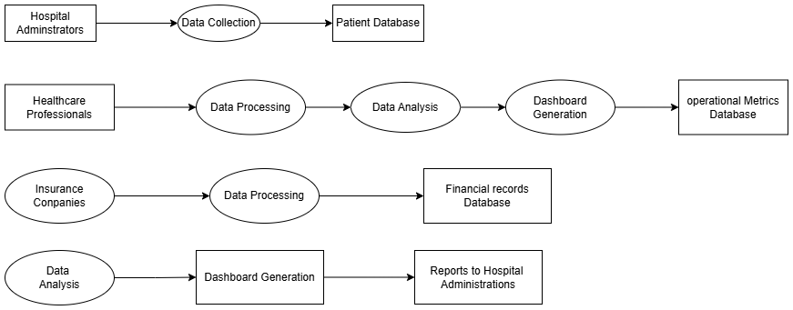

Figure 3.5.1

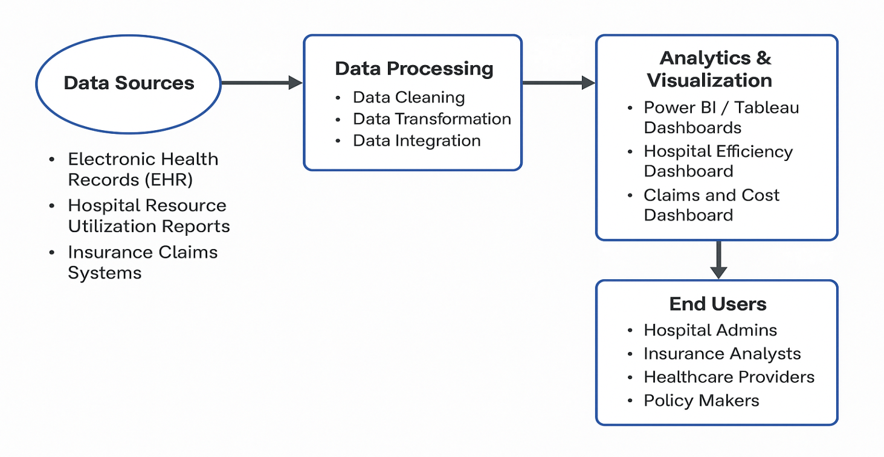
Figure 3.5.2

3.6 DATA FLOW DIAGRAM (DFD’s)

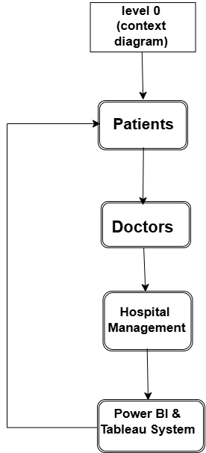

Figure 3.6.1

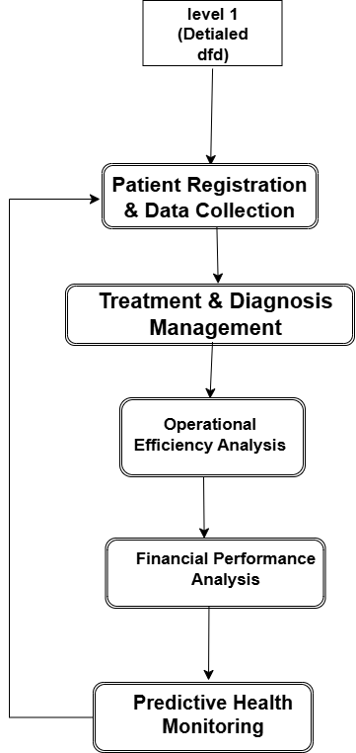

Figure 3.6.2

CHAPTER 4: EVALUATION OF TRAINING

4.1 Get Data from SQL Server or Excel Workbook:
- Excel workbook: Load data from .xlsx or xls files.
- Power BI semantic models: Connect to existing datasets/models.
- Dataflows / Dataverse: Cloud-based sources.
- SQL Server / Analysis Services: For database connections.
- Text/CSV / Web / OData feed: For structured or online data.
- Blank query: Start from scratch with Power Query.
- Power BI Template Apps: Prebuilt templates from marketplace.

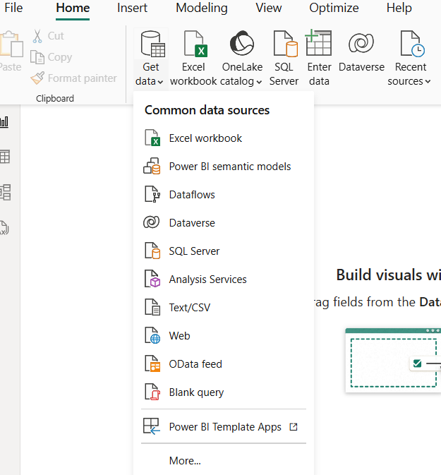

Figure 4.1.1

4.2 CSV Data Preview (‘Hospital Resource Utilization’ and Same other files)
This is the data preview window for a CSV file.
Columns: Hospital ID, Department, ICU Occupancy, Staff on Duty, etc.
Load: Load directly into Power BI.
Transform Data: Clean/edit data first in Power Query.
Cancel: Exit without loading.

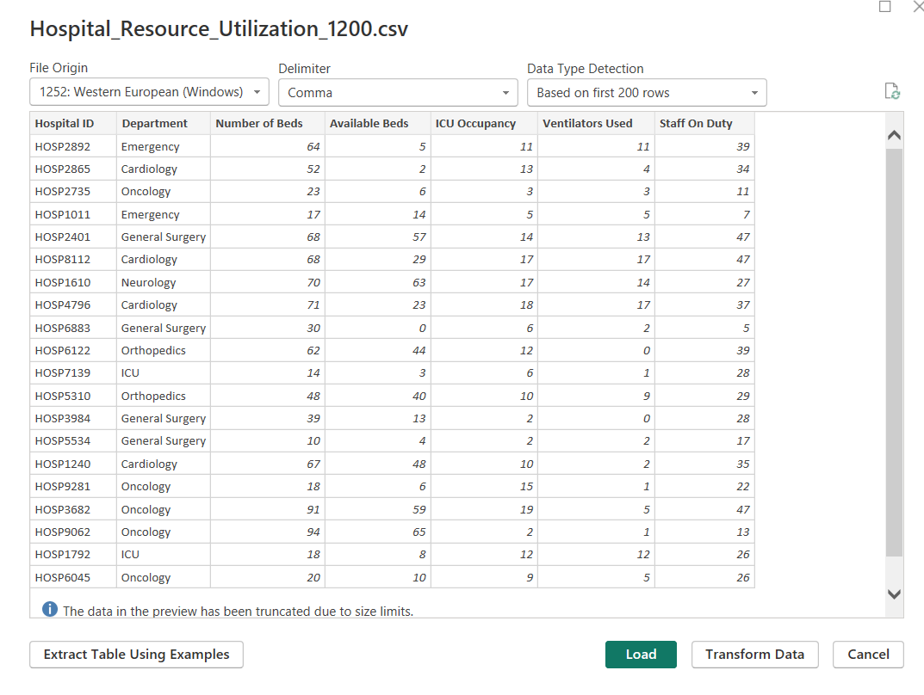
Figure 4.2.1

4.3 Transform Data Option
This shows the "Transform data" option under the Home tab.
- Purpose: Opens Power Query Editor to clean and shape data.
- Usage: You can remove columns, filter rows, split columns, change data types, etc., before loading the data.

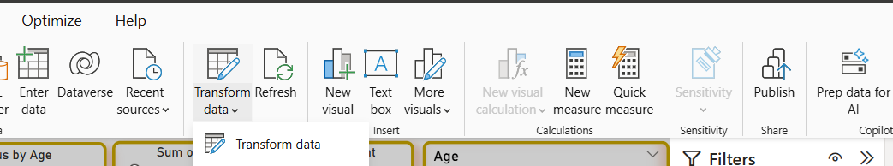

Figure 4.3.1

4.4 Data Preparation in Power Query Editor
- This image focuses on data profiling and transformation. It shows the health records table in Power Query Editor.
- You can see visual cues like "Column Quality" bars (green for valid, no red for errors, no grey for empty) indicating excellent data quality.
- The "Column Profile" for "Patient ID" explicitly states "499 (100%) Distinct, 499 (100%) Unique," meaning every patient ID is unique and there are no duplicates.
- The "Applied Steps" pane on the right shows the sequence of transformations, such as "Changed Type," where data types for columns like "Patient ID," "Age," "Gender," etc., have been correctly set.

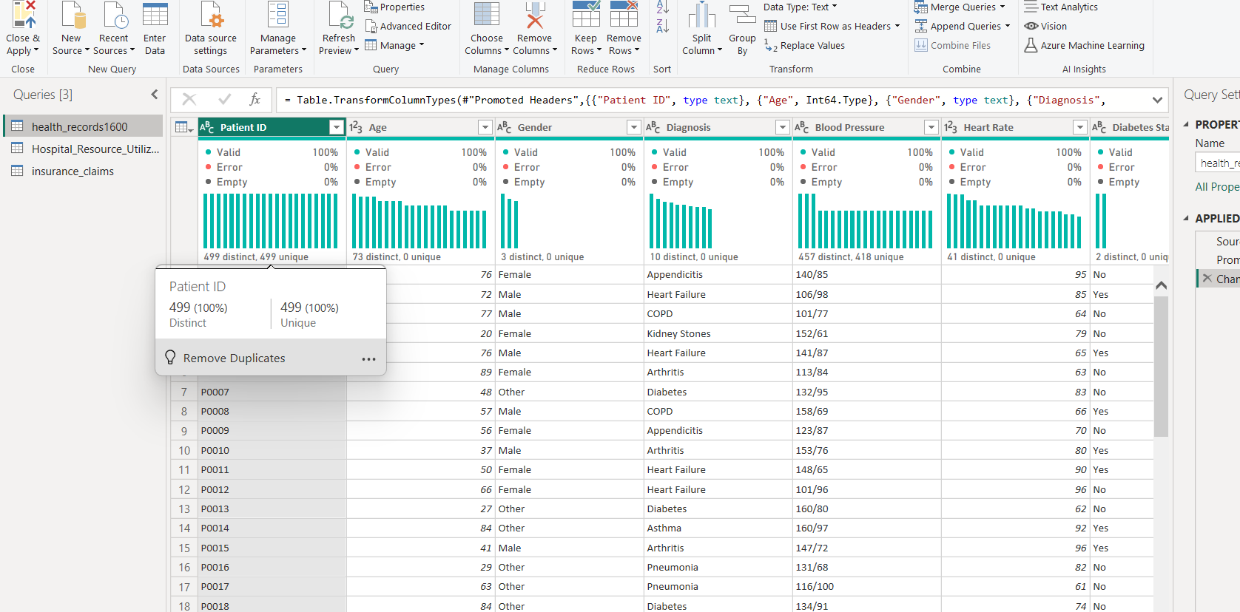

Figure 4.4.1

This image displays a data model, likely from a business intelligence tool like Power BI, showing three related tables:
- Health Records: This table contains patient health information such as Admission Date, Age, Blood Pressure, Diabetes Status, Diagnosis, Discharge Date, Gender, Heart Rate, Hospital Name, Patient ID, and Treatment Type.
- Insurance claims: This table holds details about insurance claims, including Amount Claimed, Approved Amount, Claim ID, Claim Status, Date of Claim, Insurance Provider, Patient ID, and Procedure Code.
- Hospital Resource: This table appears to track hospital resource availability and usage, with fields like Available Beds, Department, Hospital ID, ICU Occupancy, Number of Beds, Staff on Duty, and Ventilators Used.

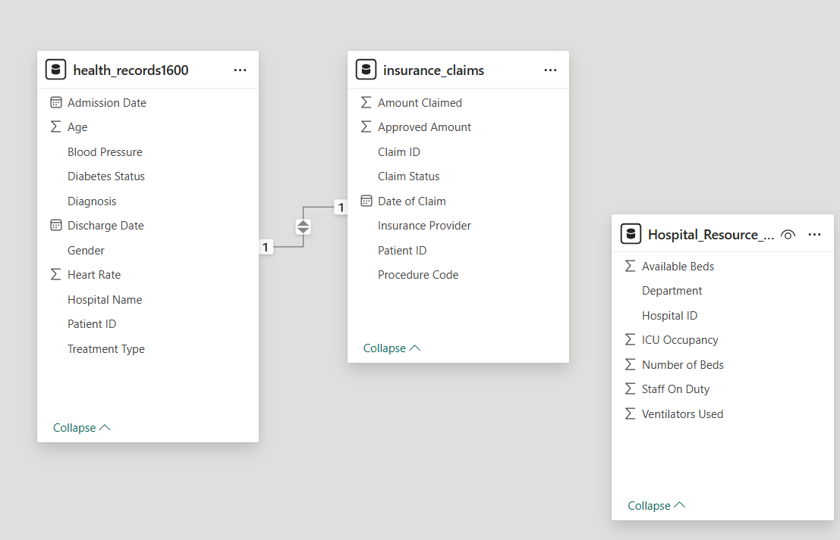

Figure 4.4.2

4.5 Power BI Report Canvas
This is the main report-building interface in Power BI Desktop.
- Left pane: Navigation between pages.
- Filters: Apply filters to visuals, pages, or all pages.
- Visualizations: Choose and customize visual types (bar, pie, map, etc.).
- Data: Fields from loaded datasets, categorized into tables.

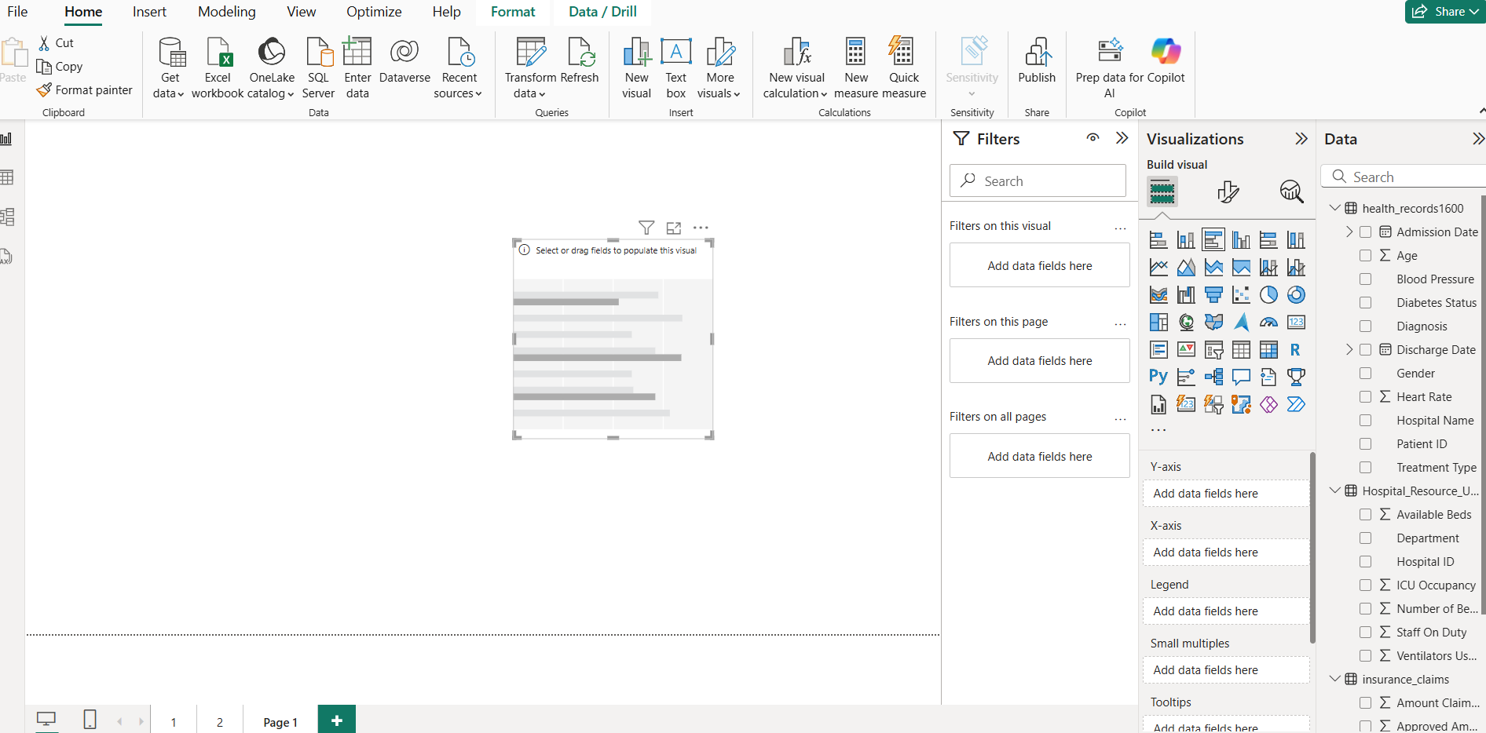

Figure 4.5.1

4.5.1 Visualizations
Chart 1: Count of Diagnosis by Gender
- Type of Chart: Horizontal Bar Graph
- Purpose: This chart visualizes the distribution of diagnoses across different genders.
- Key Information Displayed:
- Gender: The Y-axis represents the gender categories: Male, Female, and Other.
- Count of Diagnosis: The X-axis represents the count of diagnoses.
- Data Points: Male: 184 diagnoses, Female: 161 diagnoses, Other: 134 diagnoses
- Explanation: The chart clearly shows that "Male" individuals have the highest number of diagnoses (184), followed by "Female" (161), and then "Other" (134). This suggests that in the dataset, males account for the largest share of diagnoses compared to females and individuals categorized as "Other."

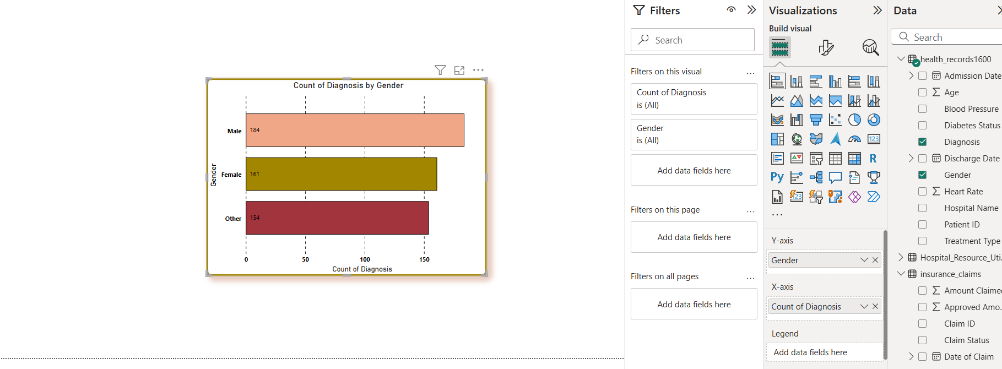

Figure 4.5.1.1

Chart 2: Count of Claim Status by Claim Status
- Type of Chart: Pie chart
- Key Information Displayed:
- Claim Status: The chart segments represent different claim statuses: Pending, Approved, and
Denied.
- Count of Claim Status: The number of claims for each status is shown inside or next to each
segment.
- Percentage: The percentage of each claim status out of the total is also provided.
- Data Points:
  - Pending: 185 claims (35.86%)
  - Approved: 171 claims (34.27%)
  - Denied: 168 claims (33.67%)
- Explanation: The donut chart effectively breaks down the total claims by their status. It reveals that "Pending" claims constitute the largest portion (35.86%), closely followed by "Approved" claims (34.27%), and then "Denied" claims (33.67%). This indicates a relatively even distribution among the three claim statuses, with a slight edge for pending claims.
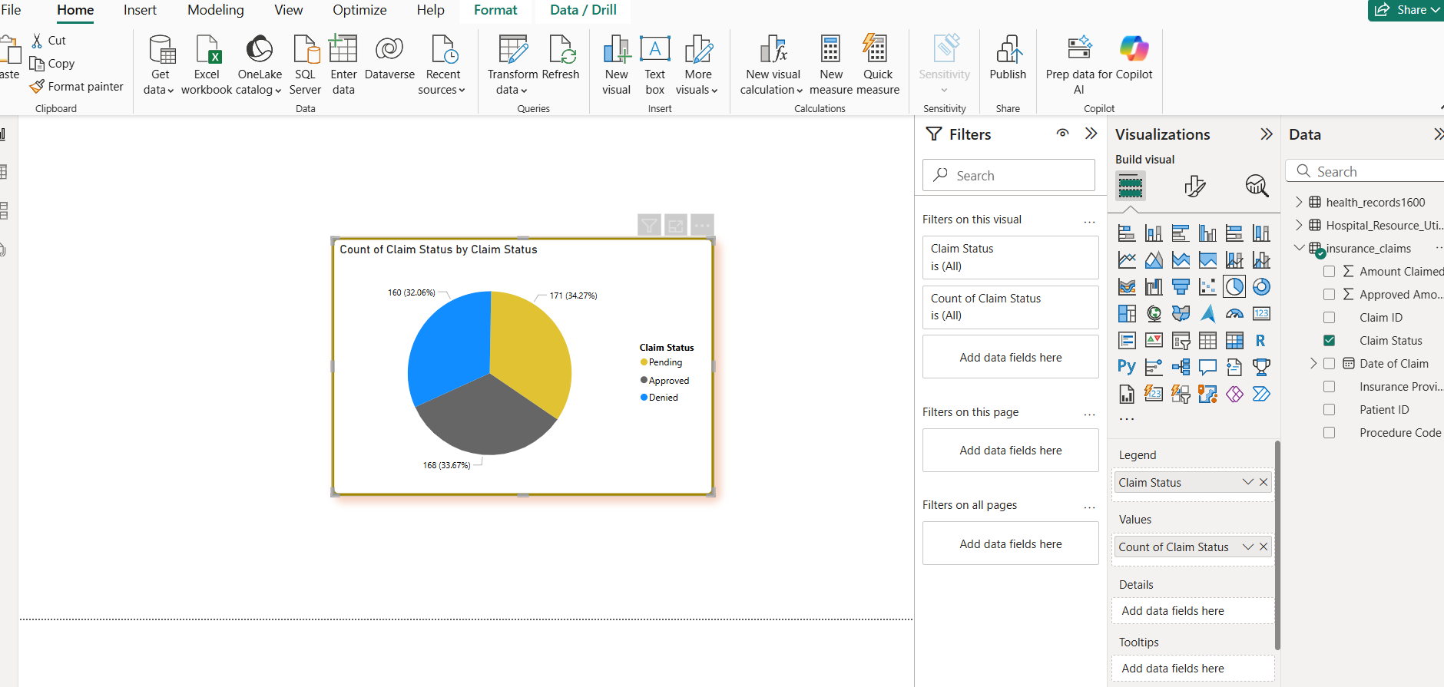

Figure 4.5.1.2

Chart 3: Slicer
- Purpose: The purpose of this visual is to allow users to filter data based on the month of the "Date of Claim". It provides an interactive way to narrow down the dataset to specific months.
- Key Information Displayed: It displays all twelve months of the year (January through December) as selectable buttons.
- Explanation: This slicer is set up to filter the data by the "Date of Claim - Month" field, which is derived from the "Date of Claim" column in the "insurance claims" table. By clicking on any of the month buttons, the user can dynamically filter all other visuals on the report page (if they are connected to this filter) to show data only for the selected month(s). The current filter setting for "Date of Claim - Month" is "is (All)", meaning no specific month is currently selected, and all months' data is being displayed.
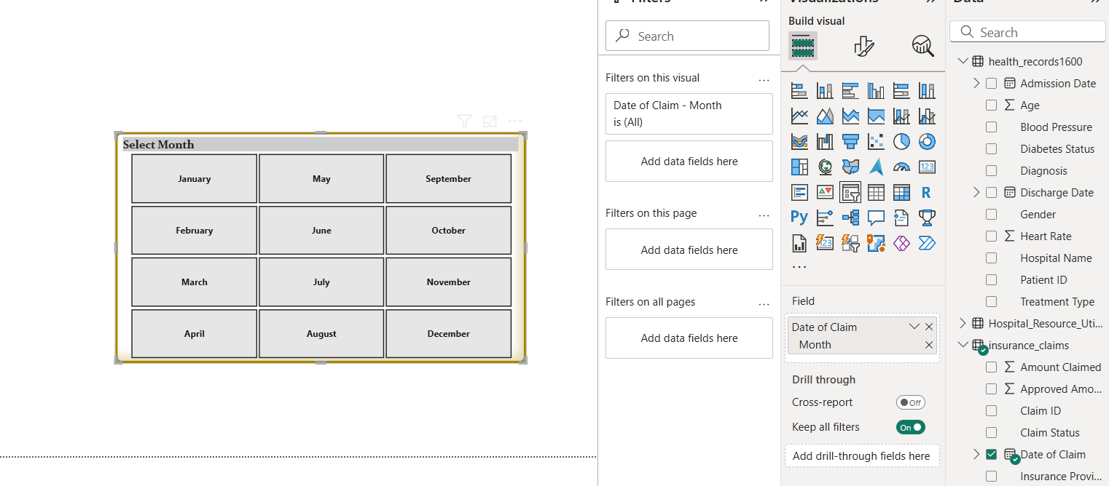

Figure 4.5.1.3

4.6 Results:
FIRST DASHBOARD
SMART HEALTHCARE INSIGHTS
This dashboard appears to focus on various operational and patient-centric metrics within a healthcare setting.
Overall Theme: The dashboard presents key performance indicators related to patient demographics, bed occupancy, staffing, and specific health conditions like diabetes.
Key Components and Explanations:
- Diabetes Status Slicer:
  - Function: Allows filtering the entire dashboard by "Diabetes Status" (Yes/No).
  - Insight: Enables analysis of other metrics specifically for diabetic or non-diabetic patients.
- Department Slicer:
  - Function: Allows filtering the dashboard by different "Department" categories (Cardiology,
Emergency, General Surgery, ICU, Neurology, Oncology, Orthopedics, Pediatrics).
  - Insight: Provides a way to drill down into department-specific data for various metrics.
- Count of Diabetes Status by Age:
  - Type: Line/Area Chart with a scatter plot overlay.
  - X-axis: Age (0 to 100).
  - Y-axis: Count of Diabetes Status.
  - Insight: Shows the distribution of diabetes cases across different age groups. The fluctuating line suggests varying prevalence of diabetes at different ages.

- Sum of Available Beds by Department:
  - Type: Bar Chart.
  - X-axis: Department.
  - Y-axis: Sum of Available Beds (in Thousands).
  - Insight: Displays the total number of available beds in each department.
- Age Slicer/Range Selector:
  - Function: Allows filtering data by a specific "Age" range (18 to 90).
  - Insight: Enables focusing on patient data within a particular age bracket.
- Average of Heart Rate by Diagnosis:
  - Type: Bar Chart.
  - X-axis: Diagnosis (e.g., Appendicitis, Arthritis, Asthma, COPD, Heart Failure, Hypertension, Diabetes).
  - Y-axis: Average Heart Rate.
  - Insight: Compares the average heart rate for patients with different diagnoses. For example, patients with "Asthma" show an average heart rate around 81.98, while "Heart Failure" is around 78.28. This could be useful for understanding physiological responses associated with different conditions.
- Count of Staff on Duty by Department:
  - Type: Bar Chart.
  - X-axis: Count of Staff on Duty.
  - Y-axis: Department.
  - Insight: Shows the number of staff members on duty per department. Neurology and Oncology
have the highest staff count (71 and 70 respectively), while Cardiology and ICU have fewer
staff (52 each). This is vital for staffing level assessment and resource allocation.
- Staff On Duty Range Selector:
  - Function: Allows filtering by a range of "Staff on Duty" (e.g., 5 to 50, though the current visual shows the range 5-50, and the staff count values like 71 are outside this range, suggesting the filter might be set differently or not applied yet).
  - Insight: Useful for analysing performance or outcomes based on varying staff levels.
- ICU Occupancy and Ventilators Used:
  - Type: Scatter Plot.
  - X-axis: ICU Occupancy (0 to 20).
  - Y-axis: Ventilators Used (0 to 20).
- Count of ICU Occupancy by Department:
  - Type: Bar Chart.
  - X-axis: Count of ICU Occupancy.
  - Y-axis: Department.

  - Insight: Displays the number of ICU occupancy instances associated with patients from different departments. Neurology (71) and Oncology (70) have the highest ICU occupancy counts, while Cardiology (52) and ICU (52, likely indicating direct admissions to ICU not categorized under other departments) have fewer. This highlights which departments' patients most frequently occupy ICU beds.
- Average of Age by Blood Pressure:
  - Type: Table/Matrix with average age values.
  - Rows: Blood Pressure ranges (e.g., 108/65, 113/64).
  - Columns: Average Age (all values are 90.00 or 89.00 in the visible portion).
  - Insight: This table shows the average age of individuals for different blood pressure ranges. The uniformity of the average age (90.00/89.00) across various blood pressure readings might suggest a specific age group is being predominantly analysed or that the data is limited, or possibly a filter is applied elsewhere.

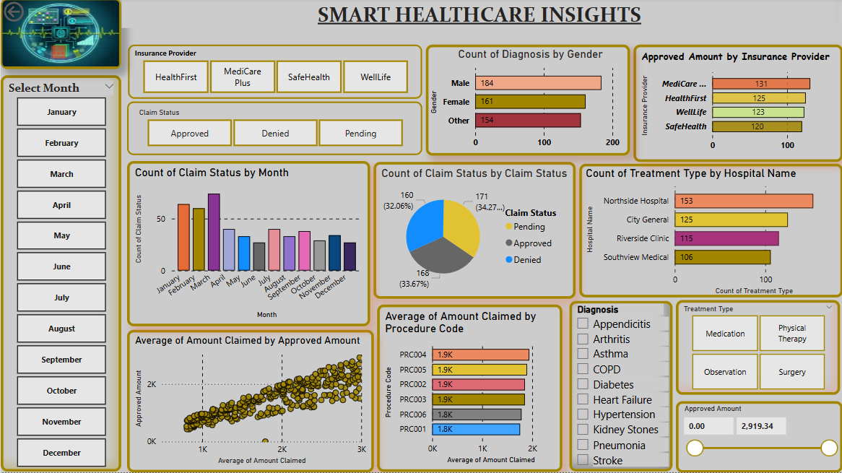

Figure 4.6.1

SECOND DASHBOARD
- Select Month Slicer:
  - Function: Allows filtering the entire dashboard by month (January to December).
  - Insight: Essential for Analysing claim and treatment trends on a monthly basis.
- Insurance Provider Slicer:
  - Function: Allows filtering by different "Insurance Providers" (Healthfirst, Medicare Plus, Safe health, Well life).
  - Insight: Enables comparison and analysis of claims and treatment data specific to each insurance provider.
- Claim Status Slicer:
  - Function: Allows filtering by "Claim Status" (Approved, Denied, Pending).
  - Insight: Helps focus on claims of a particular status to understand associated patterns or amounts.
- Count of Diagnosis by Gender:
  - Type: Horizontal Bar Chart.
  - X-axis: Count of Diagnosis.
  - Y-axis: Gender (Male, Female, Other).
  - Insight: (Identical to "p7.png" previously analysed) Shows that Male individuals have the highest count of diagnoses (184), followed by Female (161) and Other (154).
- Approved Amount by Insurance Provider:
  - Type: Horizontal Bar Chart.
  - X-axis: Approved Amount.
  - Y-axis: Insurance Provider.
  - Insight: Displays the total or count of approved amounts for each insurance provider. Medicare... (presumably MediCare Plus) has the highest approved amount (131), followed by HealthFirst (125), WellLife (123), and SafeHealth (120). This indicates which providers have processed the highest value of approved claims.
- Count of Claim Status by Month:
  - Type: Column Chart.
  - X-axis: Month (January to December).
  - Y-axis: Count of Claim Status.
  - Insight: Visualizes the monthly trend of claim statuses. For example, January shows the highest count of claims, which then fluctuates throughout the year. This helps identify seasonal patterns or periods of high/low claim activity.
- Count of Claim Status by Claim Status:
  - Type: Donut Chart.
  - Segments: Claim Status (Pending, Approved, Denied).
  - Insight: (Identical to "p8.png" previously analysed) Shows the overall proportion of each claim status. Pending claims are the largest slice (185 - 35.86%), followed by Approved (171 - 34.27%), and then Denied (168 - 33.67%). This indicates a relatively balanced distribution among the three statuses.
- Count of Treatment Type by Hospital Name:
  - Type: Horizontal Bar Chart.
  - X-axis: Count of Treatment Type.
  - Y-axis: Hospital Name (Northside Hospital, City General, Riverside Clinic, Southview Medical).
  - Insight: Shows which hospitals have conducted the highest count of treatment types. Northside Hospital leads with 153, followed by City General (125), Riverside Clinic (115), and Southview Medical (106). This can indicate hospital volume or specialization.
- Average of Amount Claimed by Approved Amount:
  - Type: Scatter Plot (likely with "Average Approved Amount" on X and "Average Claimed Amount" on Y, though the labels are cut off).
  - Insight: This chart would typically show the relationship between the average amount claimed and the average amount that was ultimately approved. A strong positive correlation (points clustering along a line) would suggest that claimed amounts are generally approved at a consistent rate. The visual suggests a positive correlation.
- Average of Amount Claimed by Procedure Code:
  - Type: Horizontal Bar Chart.
  - X-axis: Average of Amount Claimed.
  - Y-axis: Procedure Code (PRC004, PRC005, PRC003, etc.).
  - Insight: Displays the average amount claimed for different procedure codes. For example, PRC004 and PRC005 have the highest average claimed amounts (1.9K), while PRC001 has the lowest (1.6K). This helps identify the most expensive procedures on average.
- Diagnosis Filter:
  - Function: Allows filtering the dashboard by specific "Diagnosis" (e.g., Appendicitis, Arthritis, Asthma, COPD, Diabetes, Heart Failure, Hypertension, Kidney Stones, Pneumonia, Stroke).
  - Insight: Enables analysis of claims and treatment data for specific medical conditions.
- Treatment Type Filter:
  - Function: Allows filtering by different "Treatment Types" (Medication, Physical Therapy, Observation, Surgery).
  - Insight: Helps examine claim patterns or amounts associated with specific treatment modalities.
- Approved Amount Range Slicer:
  - Function: Allows filtering data by a range of "Approved Amount" (0.00 to 2,919.34).
  - Insight: Useful for analysing claims within specific approved value brackets.
In summary, these two dashboards provide a comprehensive view of healthcare operations and financial aspects, allowing users to monitor bed availability, staffing levels, patient diagnoses, claim processing efficiency, and treatment costs. The interactive filters enable detailed drill-down analysis.

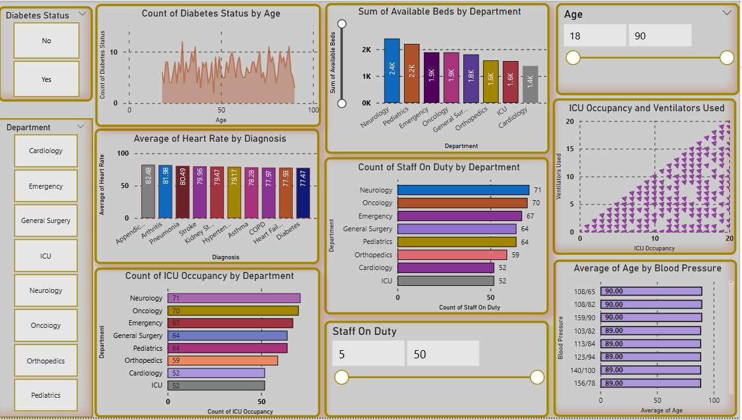

Figure 4.6.2

CHAPTER 5: CONCLUSION AND FUTURE SCOPE OF TRAINING

5.1 CONCLUSION
The literature survey highlights the significant role of data analytics, artificial intelligence (AI), and business intelligence (BI) tools in modern healthcare management. While existing systems such as Electronic Health Records (EHRs), AI-based predictive models, and BI dashboards have contributed to improving hospital efficiency and patient care, there remain several critical gaps that necessitate the development of the Smart Health Care Insights project.
Key Findings from Literature Review
5.1.1 Data Integration Challenges
o Many healthcare institutions struggle with fragmented data across multiple sources (EHRs, insurance claims, hospital databases).
- Lack of seamless integration results in data silos, reducing real-time decision-making efficiency.
5.1.2 Need for RTI
o Business Intelligence (BI) dashboards like Power BI and Tableau have been used for financial and operational reporting, but lack predictive analytics for risk management and future planning.
o Studies indicate that hospitals using real-time analytics can reduce operational inefficiencies by 20-30%.
5.1.3 Role of Predictive Analytics in Patient Care
o AI-driven predictive models help forecast disease outbreaks, readmission risks, and patient deterioration.
  - However, their adoption is low due to high costs and technical complexities.
  - Our project aims to democratize AI-driven analytics by integrating machine learning models into user-friendly dashboards.
5.1.4 Financial and Operational Optimization
  - Healthcare organizations often lack visibility into financial inefficiencies.
  - BI tools, when combined with AI-driven financial insights, can help hospitals reduce unnecessary expenditures and optimize resource allocation.

Need for SHI Project
From the literature, it is evident that existing healthcare analytics solutions either focus on operational management or predictive modelling, but rarely offer a comprehensive, integrated solution that addresses:
- Real-time hospital performance tracking
- Financial and revenue cycle analysis
- Predictive analytics for disease trends and patient risks
- Operational efficiency and resource utilization
Our project aims to bridge this gap by integrating Power BI, Tableau, AI-driven predictive analytics, and real-time data processing, ensuring hospitals can make better, faster, and data-driven decisions.
5.2 Future Scope
- Expansion to Telemedicine & Remote Monitoring: Future versions of the system could integrate with wearable devices and IoT-enabled health tracking.
- AI-Driven Personalized Healthcare Recommendations: Predictive models can be enhanced to recommend personalized treatment plans based on patient history.
- Blockchain for Secure Patient Data Management: Future improvements could focus on secure, decentralized patient data sharing using blockchain technology.
Final Thought
The Smart Health Care Insights project is a transformational step in leveraging AI and business intelligence for smarter healthcare management. By combining predictive analytics, financial intelligence, and operational efficiency tools, it provides a cost-effective, scalable, and impactful solution that can revolutionize healthcare decision-making and improve patient outcomes.
5.3 APPLICATIONS
- MY SQL SERVER
- SQL SERVER MANAGEMENT
- POWER QUERY EDITOR
- GOOGLE COLAB
- POWERBI
- TABLEAU

CHAPTER 6: REFERENCES

[1]. The New England Journal of Medicine | Research & Review Articles on Disease & Clinical
Practice
[2]. Journal of Medical Internet Research
[3]. PubMed
[4]. ScienceDirect.com | Science, health and medical journals, full text articles and books.

